Guide to DMG Calc

Video guide can be found here:
Part 1 :
https://www.youtube.com/watch?v=6Xk15X0nW48
Part 2 :
https://www.youtube.com/watch?v=HtZHb74XqTY

Main Calculation of Weapon DMG

Main explanation
BASE * (AWD+SWD) * TWD * (CHD+HSD) * DTA or DTH * DTTOOC * Other Multipliers (AMPS)

In order to have the actual calculation, all these numbers are handled as percentages and each category has to have a representation of base added into it, in the form of 1+ that percentage.
This is so you are adding a full percentage on top of base, making it for instance that if you have a 50% multiplier, you will have a 150% total of 100% base and 50% amp.
as without that representation of base of 100% in that 50% multiplication you would in effect be halving base, by multiplying it times 0.5 and halving it, not increasing it by 0.5.

Meaning the actual %-based representation of the calculation is :
BASE * (100% + AWD%+SWD%) * (100% + TWD%) * (100% + CHD%+HSD%) * (100% + DTA% or DTH%) * (100% + DTTOOC%) * (100% + Other Multipliers% (AMPS))

And converting the percentages to multipliers, the final calculation becomes :
BASE * (1 + (AWD+SWD/100)) * (1 + (TWD/100)) * (1 + (CHD+HSD/100)) * (1 + (DTA or DTH/100)) * (1 + (DTTOOC/100)) * (1 + (Other Multipliers/100))

Stats and Amps

Let's define each of these stats, and where they come from for gear.
Important to keep in mind that talents can provide these stats as well and will not show up in the stat screen, for instance the talent from coyote towards chc/chd, or chd from strained/wd from optimist.

Base is the base dmg of the weapon on the build, it is a fixed value per weapon, it is viewable in truncated form ingame, and back calculable from weapon dmg divided by (1 + ((AWD+SWD)/100)).
Also retrievable from spreadsheets like the discord or reddit ones, or my weapon dps tables.

AWD is all weapon damage stat, viewable from the stat screen.

SWD is what i call specific weapon dmg, and is the active weapon dmg of each weapon type, for instance when holding an AR, assault rifle weapon dmg is the active SWD. viewable from the stat screen.

SWD is additive to AWD and together form 1 number, before multiplying against the rest.

TWD is total weapon damage, a separate stat from WD or SWD, that will come from talents. Usually indicated on talents by having total right before weapon damage on talents. Discernible from talents on build

CHD is Critical Hit Damage, the increased dmg amount when you receive a critical hit in accordance with the CHC (Critical Hit Chance) stat. viewable from the stat screen.

HSD is HeadShot Damage, the increased dmg amount when you land a headshot, viewable from the stat screen.

CHD is additive to HSD and together form 1 number, before multiplying against the rest.

DTA is Damage To Armor, the increased damage towards Armour, white bars above health on enemies, notably purples, elites and nameds. Excludes armor plates as found on warhounds or heavies. viewable from the stat screen.

DTH is Damage to Health, the increased damage towards Health, the bars on reds and below the armour on purple and elites and includes armor plates. viewable from the stat screen.

Only one will be active at a time, at the point of transition between enemies that have both, the amount of each that is active will apply, the DTA will apply till the dmg went over into health, and from that point DTH will apply.

DTTOOC or DTOC is Damage To Targets Out Of Cover, active against enemies that are not in a cover animation, NOT viewable from the stat screen, but only a few sources exist.

Other Multipliers (AMPS), All other multipliers are going into the calculation as a their own multiplier, often called AMPS or Amplified damage as that is how some talents name them, and only come from Talents. Each AMP will act as its own multiplier and will never be additive in any form.

Stats and Amps

Here is a graphic of where every number that goes into the calculation comes from:
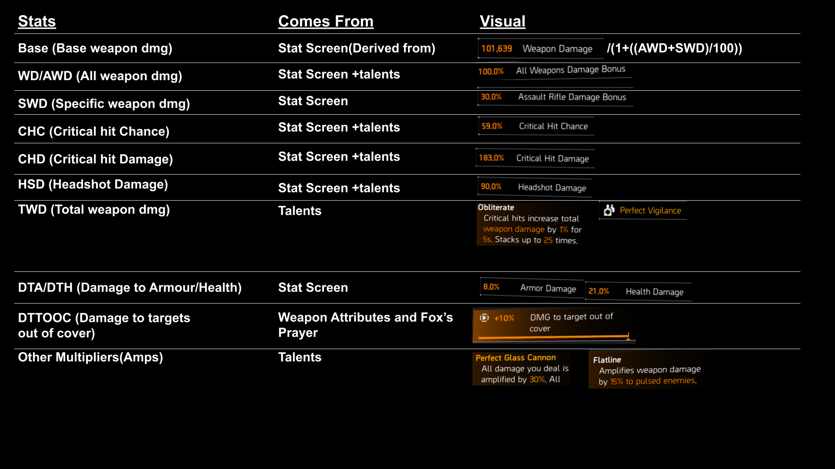

How it Calculates

AWD and SWD together are additive from all sources, and multiplies against all other stats and amps
TWD is additive from all sources, and multiplies against all other stats and amps
CHD and HSD together are additive from all sources, and multiplies against all other stats and amps
DTA/DTH is additive from all sources, and multiplies against all other stats and amps
DTTOOC is additive from all sources, and multiplies against all other stats and amps
AMPS multiply against all other stats and amps

Why it's Useful

Knowing this lets us mostly do 2 things, one is prediction, the other is verifying.

Prediction is what we do when we calculate out a build, by putting in the stats into a dmg calculator we can get the average dmg and by extension the dps’s of a build,
by having it be in stats form in a spreadsheet, we can alter parts of it and see the outcome, this is what we use to compare if one brand may be able to give you better outcomes over another, for instance.

The other is verifying, where we use it to check if stated stats are actually what they are stated to be, famously stuff like striker, the status effect weapon talents, intimidate and sledgehammer all are not the stats they state they are, and by knowing the amount we can add it to different pools or put it as a separate multiplier and verify what stat they actually are. As the calculation that matches ingame will show what it actually is calculating as.

Quirks :
Additive vs Multiplicative

Additive to itself means that a stat is adding into an already existing pool, as said in the how it calculates section, it is everything that states additive from all sources.
True multiplicatives are either some talents that are multiplicative to themselves, or only have one source and are called amplified damage or Amps for short.

In effect the same %-tage will be better if you can get it as a separate multiplier, but ingame there are no real places where you can make a choice in that way, as it is usually a multiplicative/amp like glass+vigi going up against a additive like focus+vigi, and in play those are played differently.

Also the example of focus vs glass is a good way of showing that it's not just if it is a separate multiplier or additive to an existing pool that is the most important thing, as focus ads in so much into TWD that at full stacks it easily beats glass that is an amp.
It is important to know also, that in effect, if for instance a stat is only from one source, you can consider it as a separate multiplier. So if it is glass vs focus on striker running the striker backpack, that has no other sources of TWD, then focus is acting as a separate multiplier as its the only source in that TWD pool

Separate Multipliers

Every additive to itself stat ads into its stat pool, and then multiplies against the other pools, meaning that if you could have 5% going into a already filled in pool like WD or it going into a fresh pool in the way of a unfilled stat or amp, that will act as a separate multiplier, then the separate multiplier will be the way to go.

As adding into an existing pool will give diminishing returns when viewed as the final outcome.

As a example in the following spreadsheet i have first made all stats of a glass+vigi HE red as they are in the game,
The second version is if everything was only additive to each other, instead of multiplicative.
The third is if every stat was always multiplicative, so every instance of every stat would be self multiplicative.

At the bottom I am for instance putting strikers talent, that is currently additive to itself, as a pool.
In the first it's how it is now.
In the second it's set as a self multiplicative.
Raising its talent with backpack from 100 stacks of 1 becoming 100, to self multiplicatively it will be 100 stacks of 1 becoming 170.48

https://docs.google.com/spreadsheets/d/1-DXtMlN3ew7bQGdulL1NXzmQQalyt3R7vwuxICIDLkw
(pictured below, full spreadsheet in link)
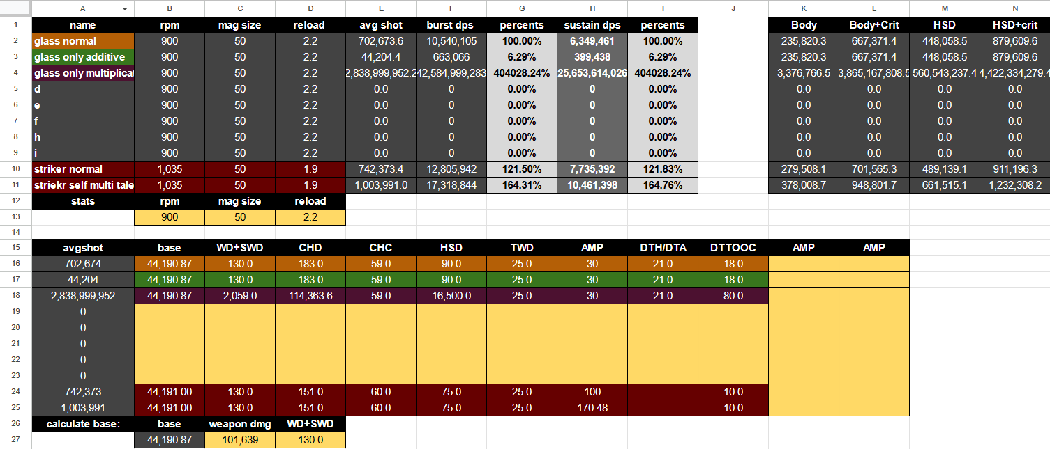

In a more relatable way, it is this that pushes good HE red builds towards diversifying their multiplier by going for DTA and DTTOOC over stacking even more CHD, as the final output will be better off with a 8% DTTOOC from fox’s prayer into a pool that will only contain the weapon attribute as well, over adding in 15% CHD from a provi or grupo brand bonus towards a heavily filled in pool.

Opportunity Cost

Additive to itself stats within a multiplicative system, such as the damage calculation that div2 uses, lead to preferring new pools for the final output if you have multiple sources.

This is because in effect the pools are increasing by the stated amount and not the whole output when you add into an already existing pool, multiplicatives and separate multipliers will increase the final output by the amount stated.

Underneath is shown 3 bars, made up of 4 chunks (representing pools adding up to a whole),
in the first we have it without anything added in,
in the second are adding 15% additive to itself into an already existing pool, taking that pool and making that 15% larger
in the third we are adding in a new pool of just 15% of the whole,
The 2nd is how additive to an already existing pool will act, the 3rd is how a new separate multiplier will act.

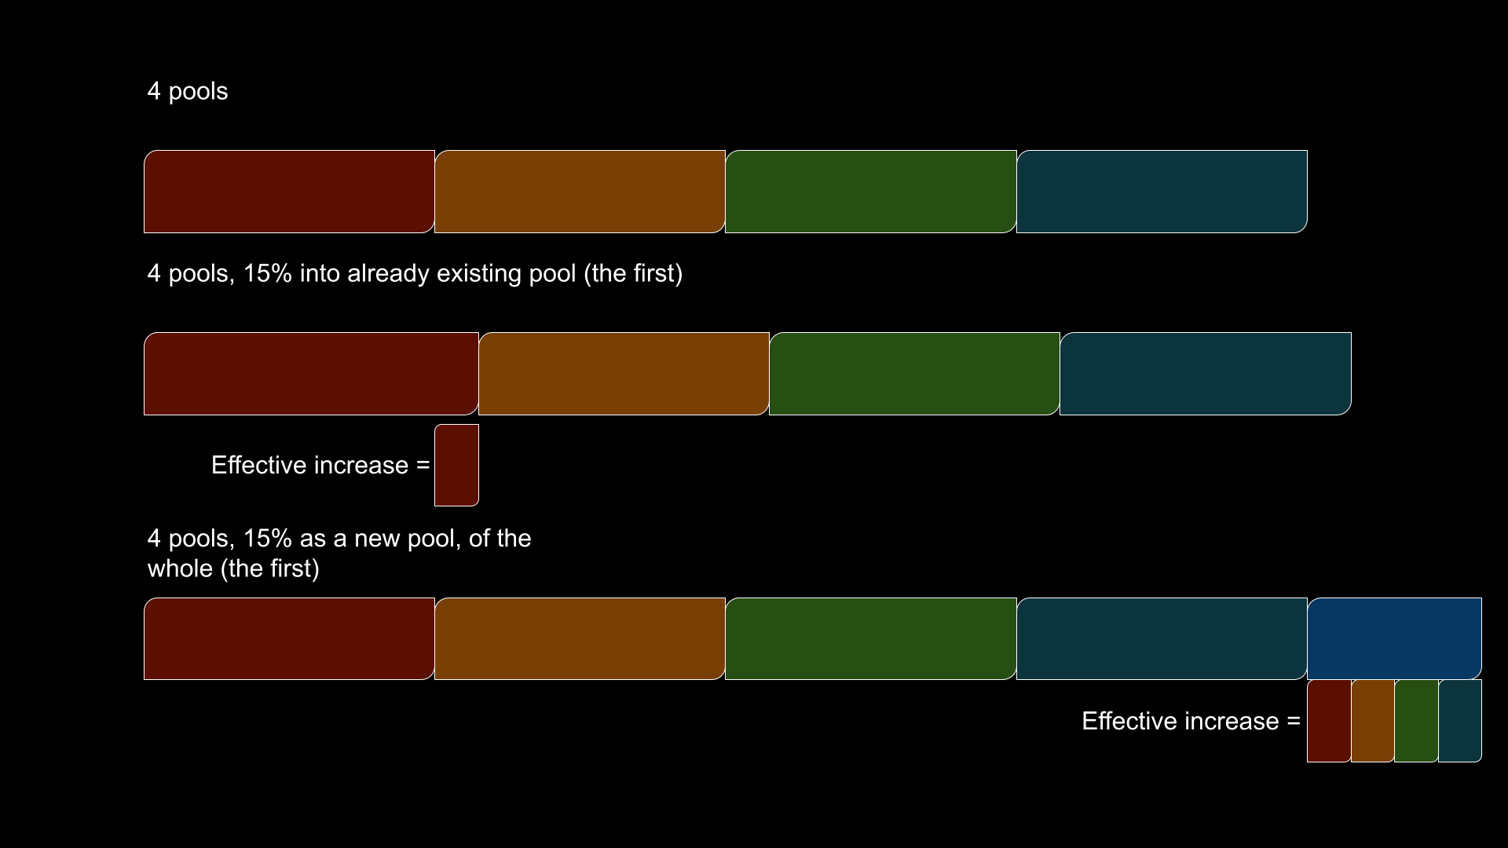

This shows what is happening when we add into one pool additively instead of increasing the whole, when we add 15% into AWD we are increasing that one pool in size by 15%, and when we add in a amp like spotters 15% we are increasing all the pools by 15%, as we are adding a separate multiplier that will increase them all.
This is the reason that increasing into a new or not heavily diminished multiplier is giving better returns per point.

So when we can, we want to diversify our multipliers over adding into existing pools if it's the same value, in the actual game of course we don't get to as easily pick between the two and it will depend, as for instance with focus vs glass as we discussed earlier.

Diminishing Returns

With the additive to itself parts of the system, we also get diminishing returns when viewed as the final outcome, this is because if you add for instance 10% to 130%, in the case of adding in fenris into an all red striker as an example.

We aren't getting a full 10% over the whole output, going from 130 to 140 is an actual increase of 4.35%, That is coming from 240/230 to give 1.04347826087 as the increase over the whole.

And the reason it is 240 as the representation of the final stat in there and not 140, is that in the calculation we add in that 100% as the a representation of the base/principal,

this is also the reason why within additive systems that at points multiply against other numbers, increases to existing pools quickly start to give worse and worse returns per point added into existing pools,
and that has made it a popular system for many games, as it is somewhat self regulating, no single stat is worth overspending within inside these systems.

Below is a chart showing how the additive to itself system will fall away as actual increase vs a multiplicative to itself stat.

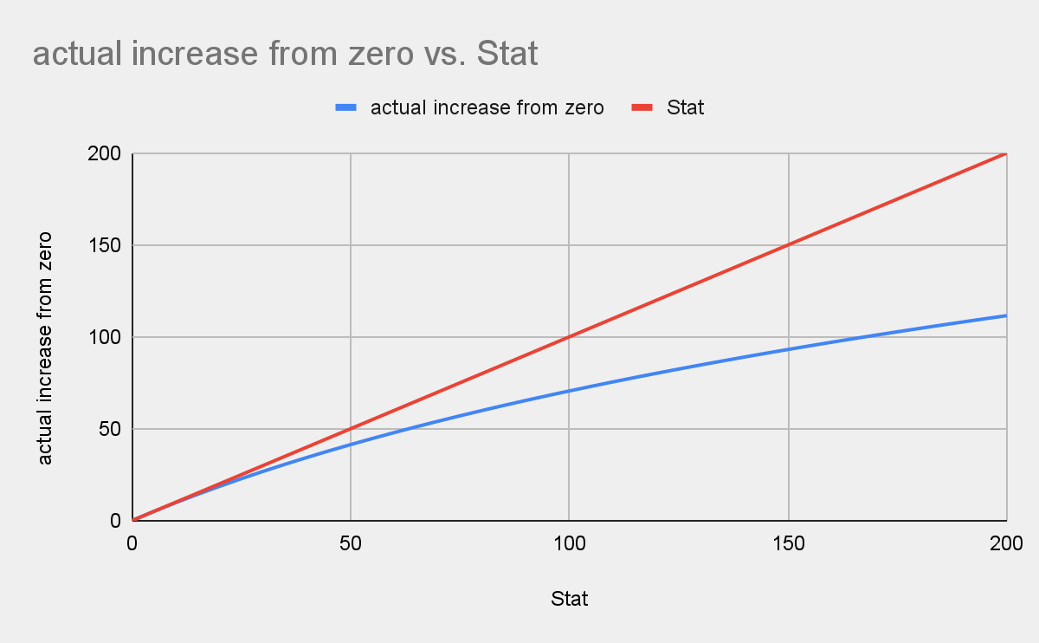

The chart is derived from this spreadsheet :
https://docs.google.com/spreadsheets/d/1MsSrTyZ9c3kBSfpXNb0Q2vF9KLj9q59IM8_ABNu5hhM

This shows how the additive to itself system gives worse returns per point added into already existing pools, and how each addition to those pools will give worse and worse diminishing returns.

Links to my other guides, the Build Collection, DMG/DPS Calculators and many other things:

https://docs.google.com/document/d/15mg-_sjowh5_8bUp2VIBqnDxCDqz-xJOISl0DlG3RDU

